This document will provide a detailed explanation to the design of the user interface to be implemented in the Graphical Enigma Simulator.

Main Menu:

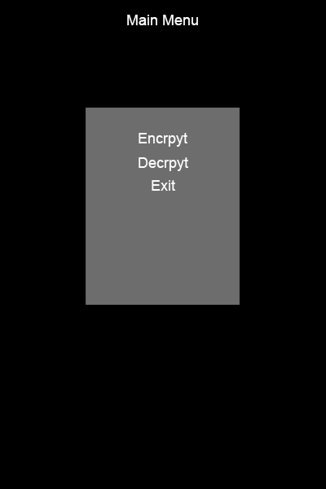

Figure 1

The image above, figure 1, represents the layout of the main menu the user shall be presented with upon starting the program. The user will then have various options to select from, encrypt, decrypt and exit.

Encrypt Screen

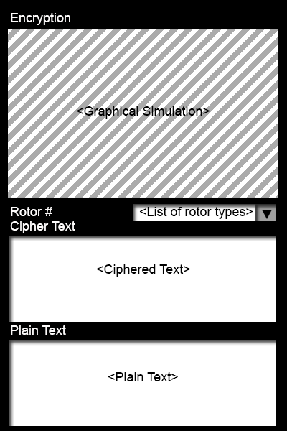

Figure 2

Figure 2 represents the layout intended to be implemented in the program. The graphical simulation shall be a 3D graphical animation which will clearly demonstrate the encryption process within an Enigma Machine.

Due to there being a number of different type of rotors available with different encryption keys, the user will be able to select from a number of different type of rotors.

The user will then enter text in the ‘plain text’ text box. Once the user enters one letter, the graphical simulation will then demostrate the encrpytion process by animating the current passing through the rotors and then encrypting that letter.

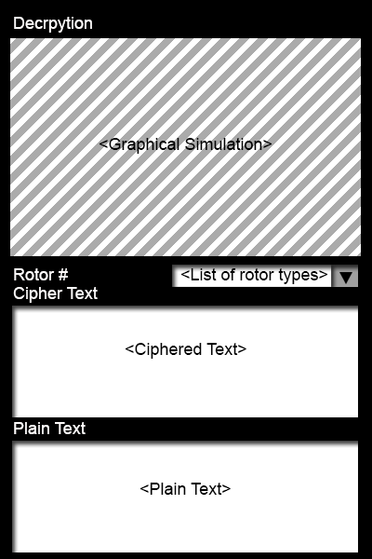Decrypt Screen

Figure 3

The decrypt screen layout is similar to the encrypt screen except that the user will be allowed to input their ciphered text and the output will be in the format of the plain text. The graphical simulation will demonstrate the process of decrypting a letter.

Alternative design layout were also explored with the possibility of having the interface in a landscape layout which would also the graphical simulation further more space on the screen which would allow the user to see more clearly the simulation.

Below are the design concepts.

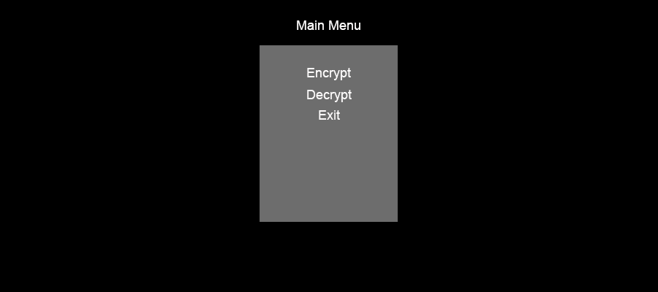Main menu screen:

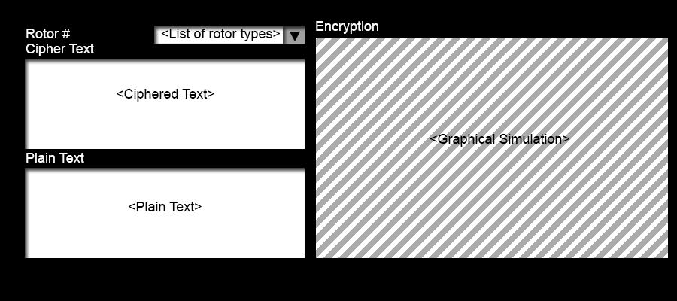Encrypt screen:

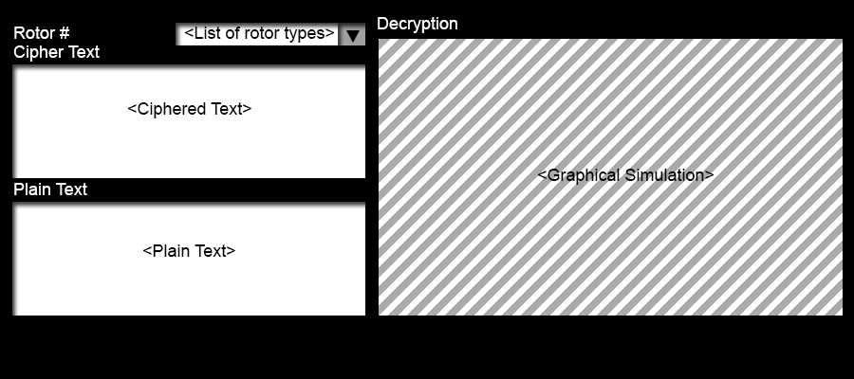Decrypt screen:

The content within the screens would remain the same, with only the screen orientation differing.